FAKE NEWS DETECTION SYSTEM USING FEATURE BASED OPTIMISED MSVM CLASSIFICATION
Scope and Limitations
Department of Computer Science and Engineering, [COLLEGE NAME]
Batch C6 (CSE-C) · Academic year [ACADEMIC YEAR]
Table 1: Project team
S.No. | Student name | Roll number
1 | Neela Mojes | 23K91A05H1
2 | Noor Saniya | 23K91A05H4
3 | Malkajgiri Akshitha | 23K91A05E2
4 | Maravajhala Radha Sri Aashritha | 23K91A05E7

Project guide: K Rajasekhar Rao
Chapter and section numbers quoted in the text (for example Chapter 8 or Section 6.2) refer to the full project report, 17.Final Document. Figures and tables in this document are numbered from 1.

1. SCOPE

1.1 In scope
• Text-only classification of an English news statement or article into REAL, PARTIALLY TRUE or FAKE, with a confidence and the three class probabilities.
• A feature pipeline of text cleaning, TF-IDF with word unigrams and bigrams, 25 handcrafted stylometric features, standardisation and PCA.
• Firefly optimisation of the PCA component subset and of the SVM parameters C and gamma; an RBF SVM with balanced class weights.
• A web application on one machine: single-text detection, batch CSV screening, model analytics, retraining on a user's labelled CSV, an About page. The command-line tools and the Streamlit app of the original library are kept.
• Evaluation on LIAR2 against stated baselines: accuracy, macro-F1, per-class precision, recall and F1, confusion matrix, cost and response time. Hardware used: Intel Core i5-12500 (6 cores, 12 threads, 3.0 GHz), 15.7 GB RAM, Windows 11 Pro, no GPU used.

1.2 Out of scope
• Checking a claim against sources or a knowledge base. The system judges how text is written, not whether it is true.
• Images, video, audio, propagation patterns, user or source credibility, and any other metadata.
• Languages other than English (the stop-word list and the cue lists are English).
• Transformer or neural-network classifiers, stemming and lemmatisation, and any GPU training.
• Authentication, multi-user operation, a database, cloud deployment and concurrent load handling.
• Use for moderation, legal or editorial decisions.

1.3 Users and environment
The intended user is a student, teacher or analyst who runs the application locally (Windows, Python 3.11 and Node.js 20 or newer, started with run.bat) and uses it as a screening aid and as a teaching example of a PCA, Firefly and SVM pipeline. The backend listens on 127.0.0.1:8406 and the frontend on port 5406; no data leaves the computer.

2. ASSUMPTIONS
• The text of a statement carries some signal about its truthfulness through vocabulary, word pairs and style. The experiments confirm a weak signal; they do not show that style causes or determines truth.
• The labels of LIAR2 are correct and the three-class mapping (true and mostly-true to REAL, half-true to PARTIALLY TRUE, the rest to FAKE) is a reasonable reading of the project's three verdicts.
• A stratified subsample of 3,000 training statements represents the full training split.
• A 3-fold cross-validated macro-F1 on the training part is a fair fitness for the Firefly search.
• Input is English text of at least five words. The API rejects shorter input.
• The application runs on a trusted local machine; the uploaded CSV is the user's own and is read by the local backend only.
• The scikit-learn version that unpickles the model is the one that produced it (1.9.x); an older version may fail to load it.

3. LIMITATIONS
The following limitations apply to the system and to the conclusions of this report. They are numbered so that other chapters can refer to them.
L1. The shipped model is trained on synthetic data. The model in models/msvm_model.pkl was fitted to 750 template sentences. Its perfect scores prove nothing about real news; on LIAR2 it reaches an accuracy of 0.192 and a macro-F1 of 0.155.
L2. The system cannot check facts. It sees words and style only. A carefully worded false claim is called REAL, and a true claim written in an accusatory tone is called FAKE (Section 8.5 of the report).
L3. The optimiser gives no demonstrated gain. Test macro-F1 is 0.429 ± 0.010 for Firefly, 0.441 ± 0.010 for the default SVM and 0.436 ± 0.009 for random search; the differences are within the seed-to-seed spread. Training takes about 504 s against 0.3 s for a linear SVM that scores better.
L4. PARTIALLY TRUE is barely learned. Its F1 is 0.24, with a precision of 0.21; half-truths do not differ from other classes in vocabulary or style.
L5. PCA is capped at 300 components. On real text this keeps only 29.3 % of the variance, although the interface and the About page say that PCA keeps 95 %. The target is reached only on the synthetic corpus.
L6. The verdict and the probabilities disagree. The verdict is SVC.predict; the probabilities are Platt-scaled and ignore the class weights. They disagree for 1,120 of 2,296 test statements (48.8 %), and PARTIALLY TRUE is never the most probable class. The confidence shown can therefore belong to another class than the verdict.
L7. Small training subsample and few seeds. The pipeline was fitted on 3,000 of 18,369 training statements because the Firefly search needs hundreds of SVM fits; three seeds give no significance test. Larger training data would very likely help (logistic regression improves from 0.470 to 0.500).
L8. One dataset, short English statements. Only LIAR2 (PolitiFact statements of about 18 words) was used. Longer articles, other sources, other languages and cross-dataset transfer were not tested.
L9. Stemming is not implemented. Objective 2 lists stemming; the preprocessing does cleaning, stop-word removal and TF-IDF only. The effect of stemming was not measured.
L10. Some interface wording assumes the demo model. The landing page strip, the note on the Analytics screen and the example chips describe a synthetic demo corpus, and stay visible when a model trained on real data is loaded.
L11. A label-column bug in the CSV loader. pandas reads a label column that contains only the words true and false as booleans, and load_csv then maps true to PARTIALLY TRUE and false to REAL. Columns with mixed LIAR labels or the project's own names are read correctly.
L12. Operational limits. There is no login, no concurrency or load test and no database; the retrain endpoint replaces the model file and allows one job at a time; uploads are limited to 25 MB and 20,000 rows for batch checks.
L13. Fixed cue lists. The sensational and credibility cue words shown on the Detect screen come from two short fixed lists, so for political claims they are usually empty.
Three figures illustrate the main limitations. The first shows how little of the feature variance the 300-component PCA cap keeps and how many components the Firefly search retains. The second shows the accuracy of the verdicts on statements of different lengths: longer statements are harder. The third shows that the verdict and the class probabilities shown in the application disagree on many statements.
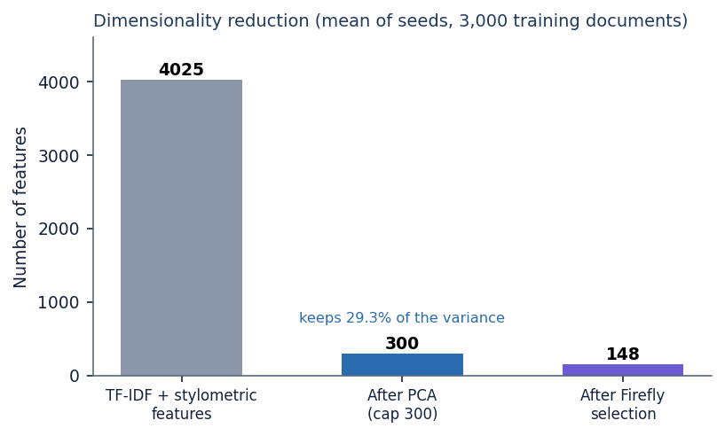
Figure 1: Feature counts after PCA and after the Firefly selection (the PCA cap of 300 components keeps only part of the variance).
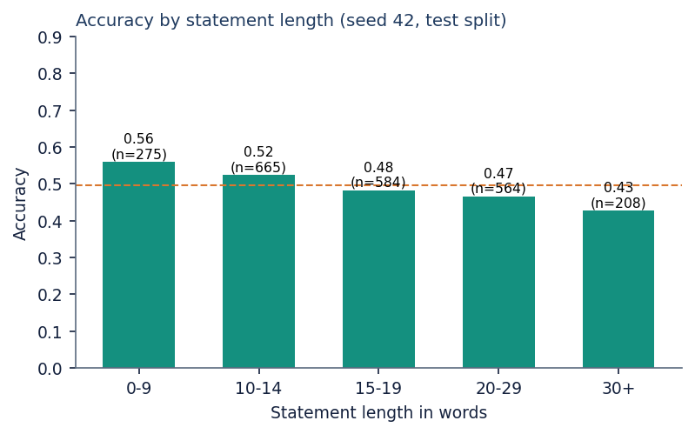
Figure 2: Accuracy by statement length on the LIAR2 test split (seed 42).
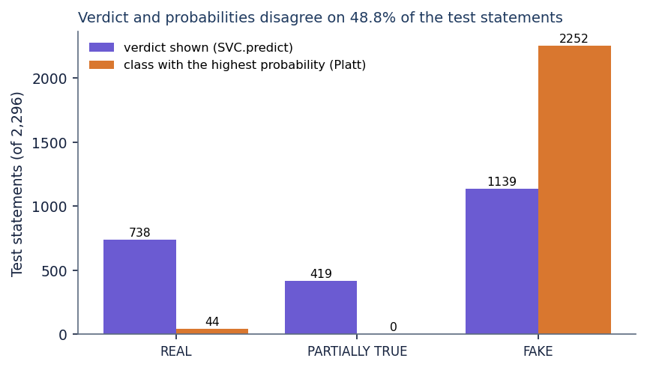
Figure 3: Verdict shown by the application against the class with the highest probability.

4. WHAT WAS NOT MEASURED
The following were not measured, and no figure for them appears in this report.
Table 2: Items not measured
Item | Why it matters | Status
Pipeline fitted on all 18,369 training statements | Shows how much of the gap to the linear models is training size | Not run (Firefly cost)
Other datasets (for example ISOT) and cross-dataset transfer | Generalisation beyond one fact-checker's statements | Not run
Statistical significance of the differences between models | Differences of 0.01 macro-F1 are within the spread of three seeds | Not tested
Different Firefly parameters, population sizes, generations and PCA caps | The defaults may be far from the best | Not varied
Effect of stemming, of the stylometric block alone and of the TF-IDF block alone | Objective 2 lists stemming; the contribution of each block is unknown | Not run
Probability calibration (reliability curve, Brier score) | Verdict and probabilities disagree | Only the accuracy per confidence bin and the disagreement rate were measured
Contextual embeddings (transformer) as features | The base paper's main ingredient | Not tried
Concurrent users, memory use under load, long-running behaviour | Deployment readiness | Not tested; only sequential requests were timed
A user study of the interface | Whether non-experts understand the verdicts | Not carried out
Security review | Upload handling and exposure beyond localhost | Input validation checked only

